You’re asking the right question — this is exactly where most people get confused.
👉 The truth is:
Step-by-Step Architecture = what happens in ONE pass
Inference Flow = how that ONE pass is repeated over time
Let’s connect them cleanly.

🧠 Core Relationship (One Line)
Inference = repeated execution of the Step-by-Step Architecture

🔁 Visual Mental Model

🔵 Step-by-Step (Single Pass Engine)
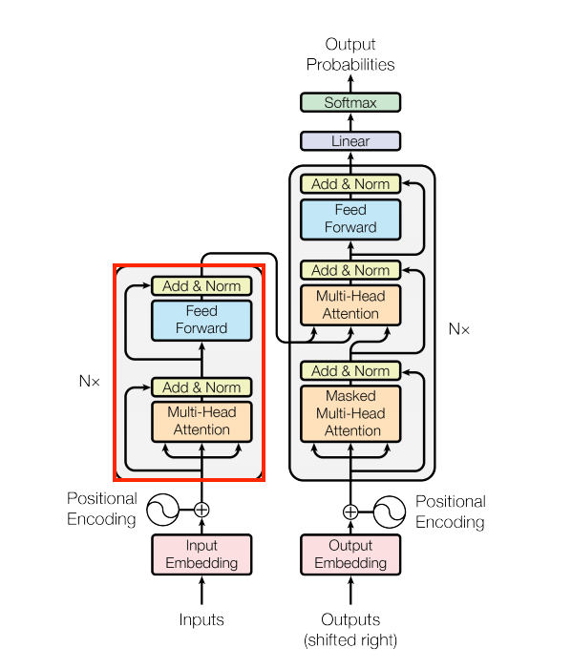
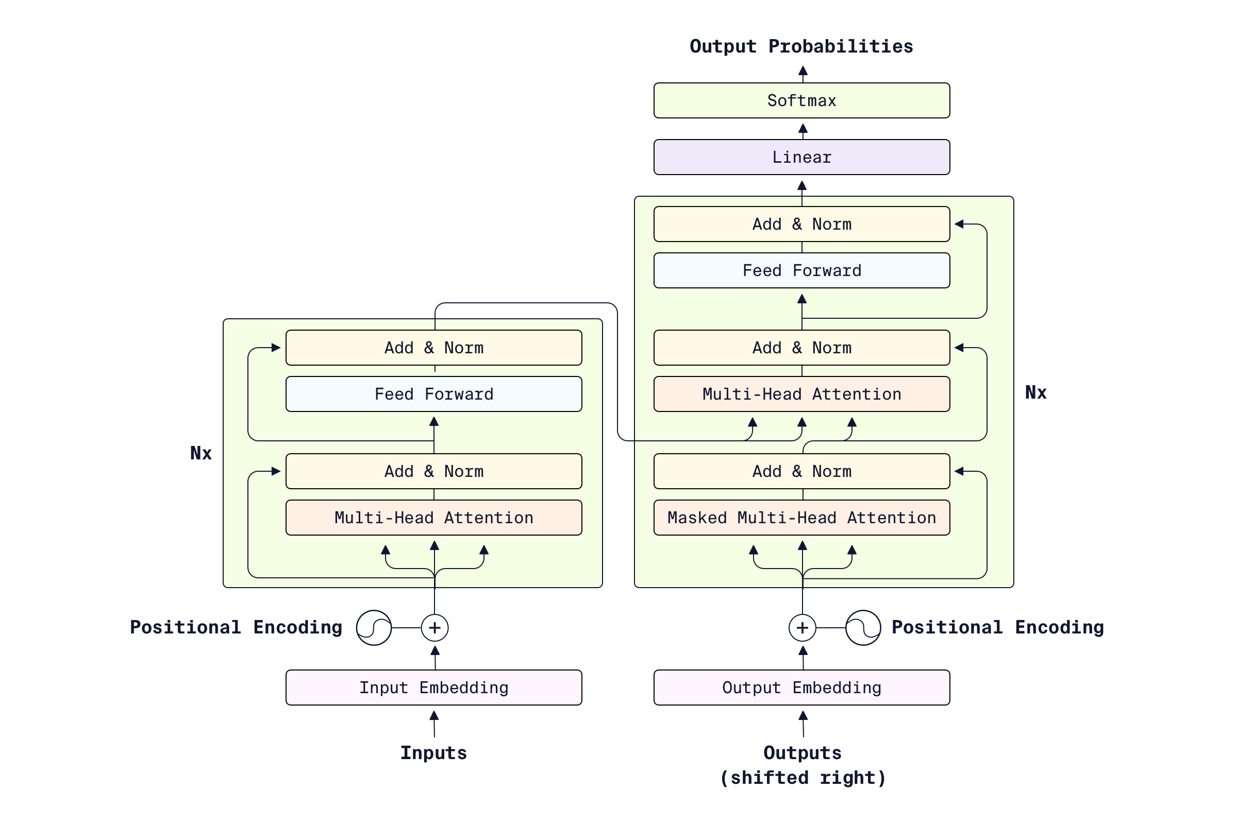
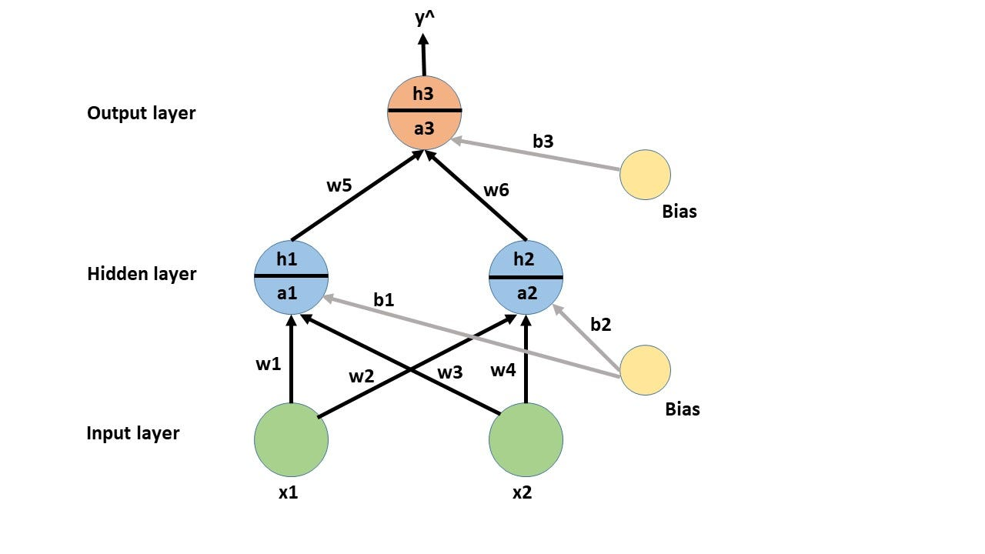
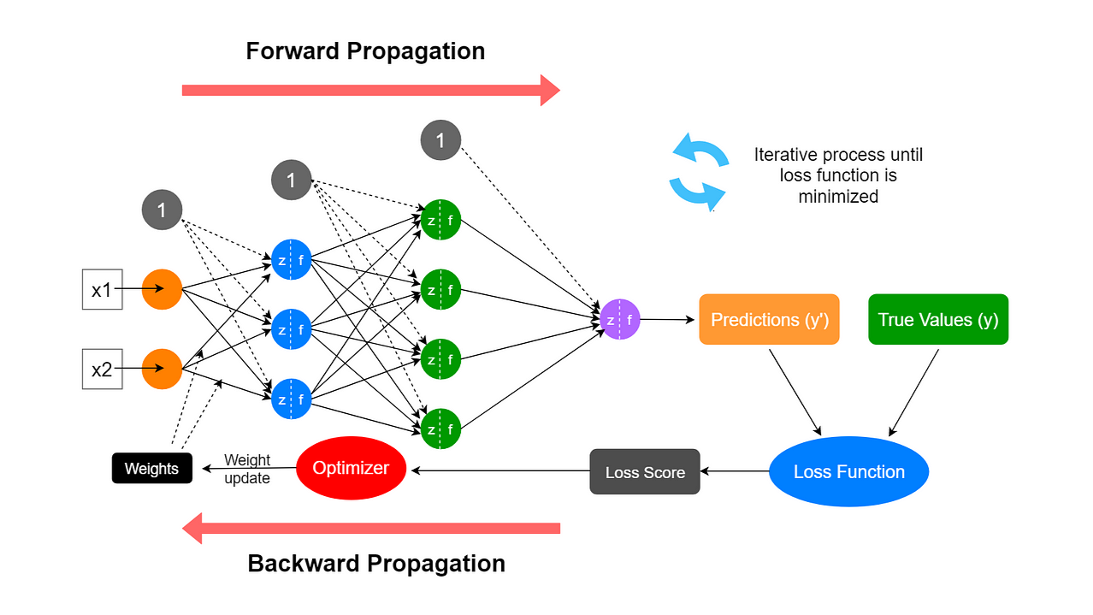
This is what happens once:
Tokens → Embeddings → Transformer Layers → Logits → Probabilities
👉 This is a pure forward pass
👉 No loop, no time dimension

🔴 Inference Flow (Loop Over Time)
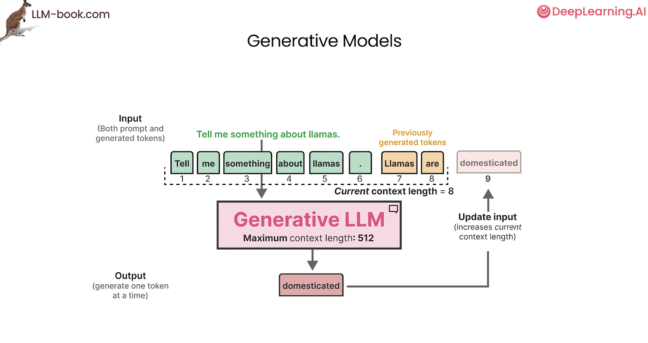

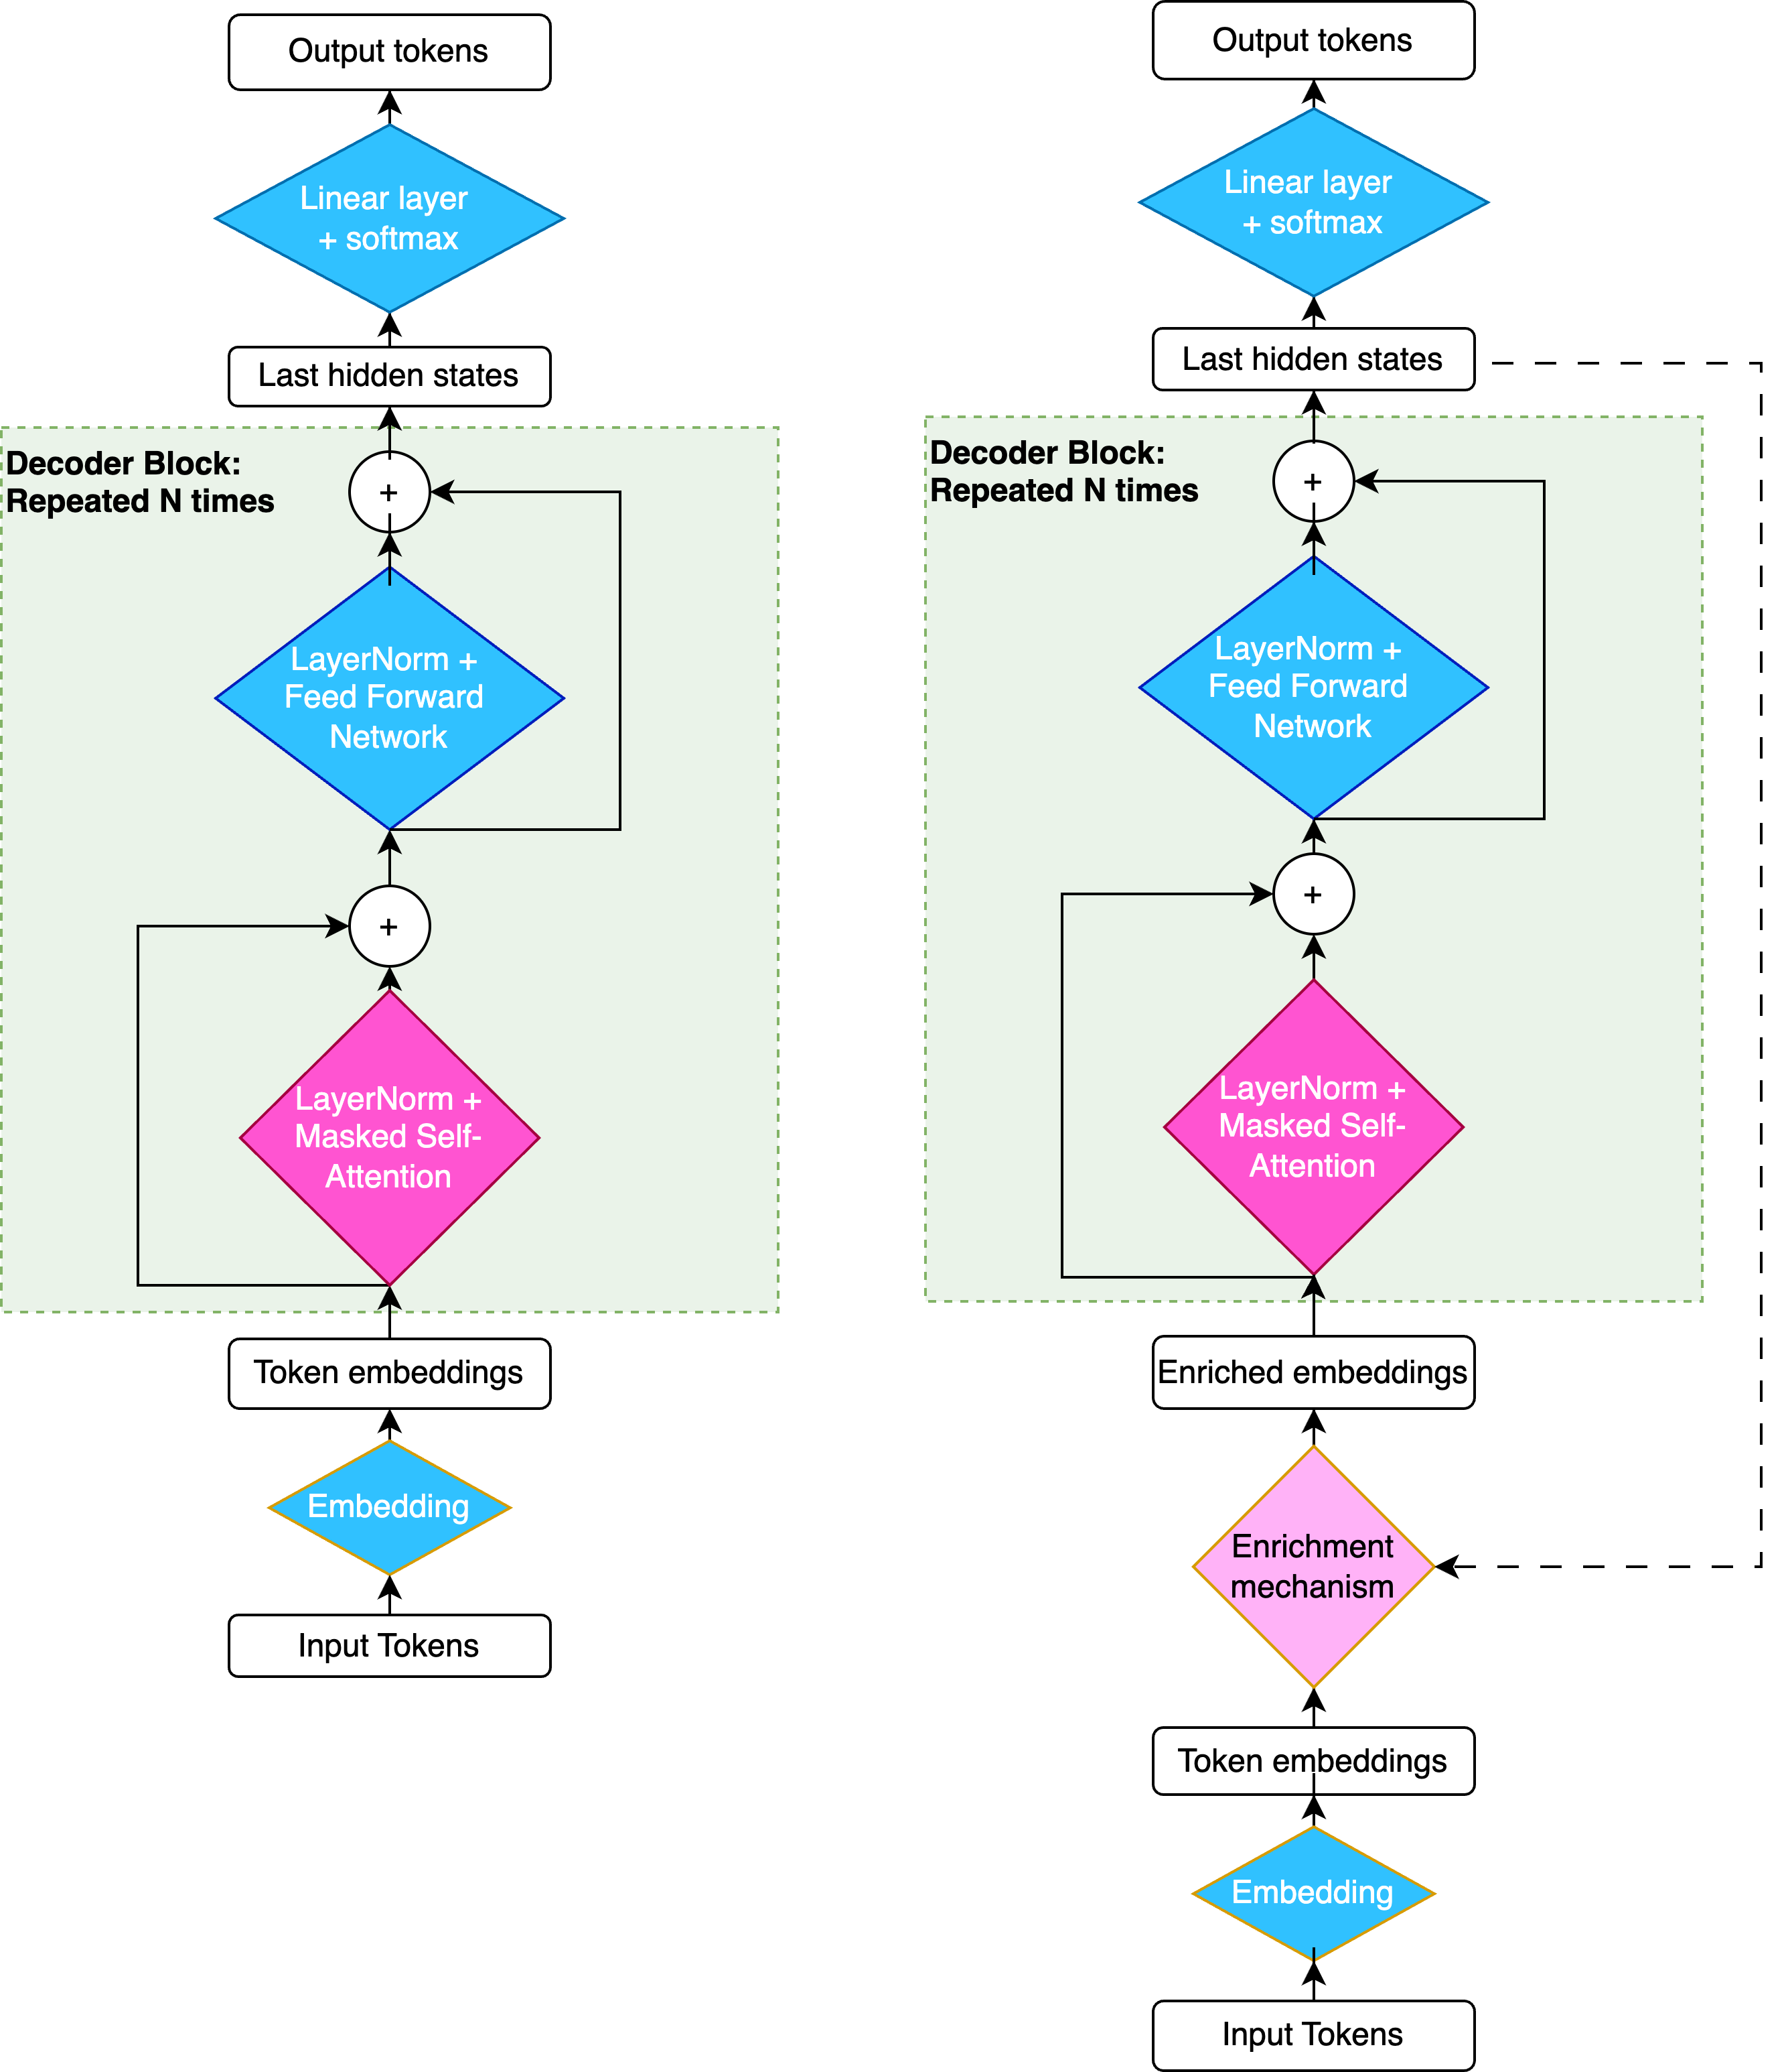
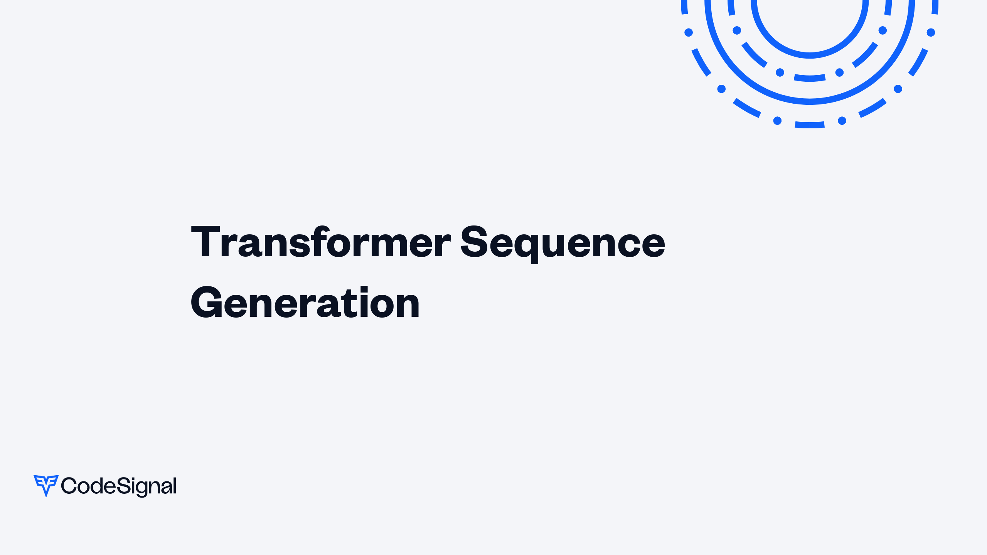
This wraps the above into a loop:
[Step-by-Step Pass] → Next Token → Append → Repeat

🔗 How They Fit Together (Step-by-Step)
Let’s map exactly what happens when you type:
"AI is"

🔹 Iteration 1

Step-by-Step runs ONCE:
- Tokenize:
- ["AI", " is"]
- Pass through architecture:
  - Embedding
  - Attention
  - FFN
  - Output logits
- Softmax → predict:
- " powerful"

🔹 Iteration 2
Now inference loop updates input:
"AI is powerful"
👉 AGAIN runs full Step-by-Step architecture:
- All tokens processed again
- Attention recalculated
- New logits generated
→ predicts next token

🔹 Iteration N
"AI is powerful because..."
Same thing:
- Full forward pass
- Predict next token
- Repeat

⚡ Key Insight (CRITICAL)

❗ The model does NOT “continue from where it left off”
Every step:
- Re-runs the entire architecture
- On the entire sequence so far

🧠 Why This Matters

1. Computational Cost
Because:
Step-by-Step runs N times → O(N²) attention cost
👉 This is why LLMs are expensive

2. KV Cache Optimization
To avoid recomputing everything:
- Models store:
  - Keys (K)
  - Values (V)
👉 So next iteration:
- Only new token is processed fully
- Old context reused

3. Context Awareness
Each iteration:
- Model sees entire updated sentence
- So output adapts dynamically

🏗️ Architecture vs Runtime (Perfect Mapping)
Concept | Role
Step-by-Step Architecture | Execution engine (forward pass)
Inference Flow | Orchestrator (loop controller)

🔄 Software Architecture Analogy (For You)
Since you're a system architect:

Step-by-Step =
processRequest(input) → output

Inference Flow =
while (!done) {
output = processRequest(currentInput);
currentInput += output;
}

🔥 Deep Insight (Most Important)
The Transformer is stateless
The sequence is the state
Meaning:
- Model doesn’t “remember”
- Context is rebuilt every iteration via tokens

🚀 Final Mental Model
Inference Flow
= Loop
→ calls Step-by-Step Architecture
→ generates 1 token
→ updates input

⚡ One-Line Summary
Step-by-Step = one forward computation
Inference Flow = repeated forward computations forming a sequence

If you want, next I can:
- Show tensor shapes at each iteration
- Explain KV cache with real matrices
- Or simulate one full inference step numerically
Just say 👍

